

|  |
| --- |
| MAKAIA FRAMEWORK |



***Overview of Hybrid Framework***

A *hybrid framework* in Selenium is an approach to structuring and organizing test automation code using a combination of different testing frameworks and techniques.

It's designed to leverage the strengths of multiple frameworks to create a *more flexible, efficient, and adaptable* test automation solution.

***The Need for a Hybrid Framework***

The core idea behind a hybrid framework in Selenium is to combine elements from various testing frameworks, such as:

***Data-Driven Framework:*** This framework focuses on separating test data from test scripts. Data is stored in external sources like *Excel sheets or databases*, and the test scripts read and utilize this data to execute tests for different scenarios.

***Keyword-Driven Framework:*** In this framework, test scripts are written using *high-level keywords* that represent specific actions or functionalities. The actual implementation of these keywords is abstracted and managed separately, making the test scripts more understandable for *non-technical stakeholders*.

***Modular Framework:*** The *modular framework* divides the application under test into smaller modules or components. Each module has its own set of test scripts, making the framework more organized and easier to maintain. This approach is particularly useful for complex applications.

***Page Object Model (POM):*** *POM* is a *design pattern* that represents *application pages as objects*. Each page object encapsulates the elements and actions on that page. A *hybrid framework* might incorporate the *POM to improve code reusability* and *maintainability*.

**Testleaf**  ***Makaia Framework:Technical Documentation***

  


**Testleaf**  ***Makaia Framework:Technical Documentation***

***TestNG or JUnit Framework:*** These are testing frameworks that provide features *for test execution, parallel testing, test grouping, and reporting*. A hybrid framework can integrate TestNG or JUnit for efficient test execution and result reporting.

*By combining these different frameworks,* ***TESTLEAF*** *has developed a hybrid framework in Selenium named* ***MAKAIA*** *which offers several benefits:*

***Flexibility:*** You can choose the appropriate testing technique for different scenarios or functionalities within your application.

***Reusability:*** Components like data sources, keywords, and modules can be reused across different test cases, enhancing code maintainability.

***Adaptability:*** As your application evolves, you can easily update or modify specific components of the framework without needing to overhaul the entire structure.

***Comprehensive Testing:*** Hybrid frameworks provide the ability to perform data-driven, keyword-driven, and modular testing simultaneously, leading to more comprehensive test coverage.

***Clear Reporting:*** The integration of testing frameworks like TestNG or JUnit offers advanced reporting capabilities, making it easier to analyze and interpret test results.

***Cross-Functional Collaboration:*** The use of high-level keywords and modular components makes the framework more accessible to non-technical team members, promoting effective collaboration between testers, developers, and business stakeholders.

**Makaia Framework Components**

* ***Selenium with Java*** is used for interacting with the *WebElements* of a web application.
* The test run is accomplished through the utilization of the ***TestNG framework.***
* The *BDD approach* has also been integrated into the framework with the assistance of the ***Cucumber tool.***
* ***Apache POI*** is utilized to manage external data, such as Excel files that helps to access multiple data sets required for the project.
* ***Properties files*** for handling *multilingual and type safe data* are maintained.
* *HTML reports* are generated for each step of the test cases using ***Extent Report.***
* All these integrations are achieved through ***Maven build tool*** for *easy maintenance* and *provides flexibility* for the automation process.
* The framework is designed based on the *design pattern* ***POM (Page Object Model)*** and it integrates both *API and Browser Automation Testing*.

**Framework Architecture**

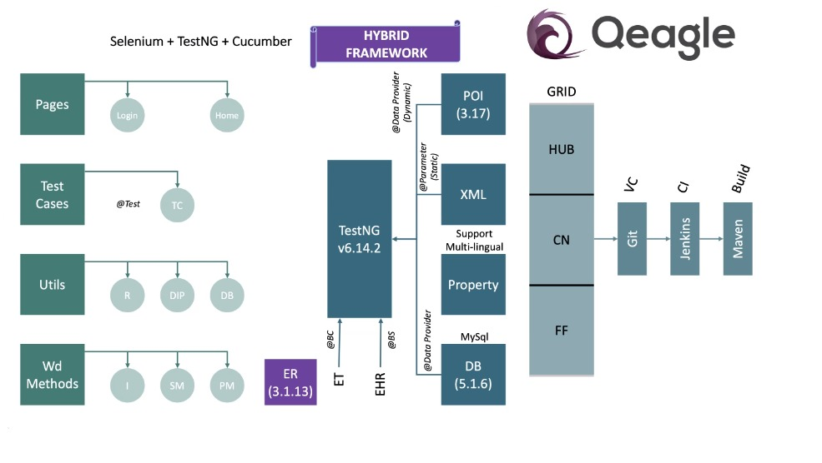

**Testleaf**  ***Makaia Framework:Technical Documentation***



**Framework Structure**

***First Level***

* ***Pages:*** Pages all the methods which indicates the navigation within the application**.** Each page will have class file where the corresponding methods required for the page is implemented.
* ***Testcases:*** The class file where the specific test case starts its execution using *TestNG* runner class.
* ***Utils:*** The component helps to hold the external data files such as database, excel files and also the *reporter class* to capture the status of the project. It also holds the *reporter configuration* for the entire project.
* ***WebDriver Methods:*** The component is composed of all the *interfaces and wrapper methods* which are required to interact with the *WebElements*.

***Second Level***

* ***TestNG:*** The *TestNG* components serve as the execution platform for the entire project, encompassing the other frameworks for the integration of

**\*** *Dynamic data* which are maintained in Excel format are handled with Apache POI

**\*** *Multilingual data* and other common data with XML are maintained using Property file.

**\*** *Owner API* to read and manage the data from various sources such as properties file, environment variables and system properties. It also provides type safe configuration.

***Third Level***

The third level of components communicate with ***the CI/CD tools like Jenkins*** and uses ***version control tool such as GIT***. ***Grid module*** supports the Cross-browser testing.

**Testleaf**  ***Makaia Framework:Technical Documentation***

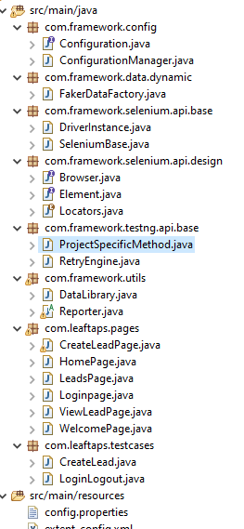

*Let's delve into understanding the process of implementing a framework within the project.*

***Selenium Design***

Selenium Design package holds three separate interfaces namely *Browser interaction, WebElement Interaction and the Locators* to communicate with the Browser elements.

***Browser Interface***

A *browser interface* class has been created containing all the necessary methods for interacting with the browser. These browser commands include both preconditions and post-condition methods.

***Element Interface***

The *Element interface* class is designed with all the actions related to the web applications.

***Locators enum***

The *locator* class is designed as enumerator type so that variables of this class will be constant and used throughout the project. The string variables used here are the locators

***ID***, ***XPATH***, ***CLASS_NAME***, ***NAME***, ***CSS***, ***LINK_TEXT***, ***PARTIAL_LINKTEXT***, ***TAGNAME***

**Testleaf**  ***Makaia Framework:Technical Documentation***



***SeleniumBase package:***

The implementation of *WebDriver Methods* is parted into two classes:

* DriverInstance
* Selenium Base

***DriverInstance***

\**DriverInstance* class is implemented for instantiating the browser driver. It follows Singleton design pattern.

**\*** The *browser driver methods* are accessed using the driver instance, and their thread safety is ensured through the utilization of the *ThreadLocal* class.

**\*** It acts as the *superclass* within the framework.

**\*** In simple words, a single, unique driver instance is used by all the testcases that helps in avoiding the ambiguity during parallel execution of testcases.

**\*** The class is structured following the principles of *Encapsulation* in Object-Oriented Programming (OOP).

**\*** The *getter and setter methods* are used to get the driver access across the classes and also to set the required driver instance and browser options.

**\*** The class can also be invoked for instances where it's necessary to pause the *polling time* for command execution. These instances are declared as *private static final ThreadLocal* fields.

**\*** The class declaration is done as   
 ***private******static******final*** *ThreadLocal<RemoteWebDriver>* ***remoteWebdriver*** *=* ***new*** *ThreadLocal<RemoteWebDriver>();*

**Testleaf**  ***Makaia Framework:Technical Documentation***



***SeleniumBase***

**\*** *Selenium base* class is a wrapper class which implements all the methods from the Browser and Element Interface class.

**\*** The class contains all the selenium and AUI Commands.

**\*** A *Retry Listener* has also been incorporated into this component to facilitate the execution of failed test cases

***TestNG Base Package***

***ProjectSpecificMethod***

*ProjectSpecificMethod* is the base class that holds the common methods which are specific to the project. For example, the common methods such as setup() and teardown() are maitained within the PSM i.e., the pre and post conditions required for the framework are implemented here.

***Reporter:***

**\*** To enhance report generation with a more interactive approach, the project has integrated the *Extent Report* library from aventstack.

**\*** The class is structured to generate reports that verify the implied commands, and any exceptions are captured within a *try-catch block.*

***Utility Package:***

***Retry Engine***

The *retry* mechanism enables automatic reruns of failed test methods a specific number of times before declaring them as failures. This proves advantageous in scenarios where *flaky tests* fail due to *intermittent issues*.

**Testleaf**  ***Makaia Framework:Technical Documentation***



***Internal Working of a hybrid framework***

**Testleaf**  ***Makaia Framework:Technical Documentation***

***Reporter***

The *Extent Report Configuration* captures the methods of every page within the application flow, incorporating them into an email attachment.

***Dynamic Data Library***

The test data for the test scripts is maintained in Excel sheet and is managed by *Apache POI*

***Properties file***

*Multilingual data* and other common data with XML are maintained using *Properties file*.

***Java Faker***

*Java Faker* used to generate *dynamic data* like name, email-id, phone numbers etc.

***Owner API***

The *Owner API* offers a *type-safe configuration* and simplifies the code needed to manage *Java properties (configuration) files*.

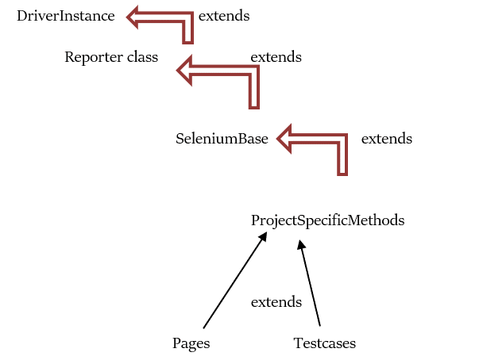



**Testleaf**  ***Makaia Framework:Technical Documentation***

* The project initiates its execution from the *TestNG runner class* file. The first step involves setting up the reporting platform, while each subsequent step captures the flow to report the application's status.
* Moving forward, the following step encompasses executing test cases, which involves configuring values such as the desired browser for the project. Subsequently, the *reporter class* is invoked to manage the method implementation flow.
* In the third step, the *DataProvider* method is called upon to provide input data to the necessary methods. Following this, the test case methods are triggered from the *ProjectSpecificMethod* class, seamlessly continuing with the implementation of all *page object methods*.
* Upon completing the implementation of all methods, the application's status is generated using the *Extent report* method.

**Hierarchy of Execution**

The sequential execution hierarchy is illustrated in the steps below

*@BeforeSuite --> Reporter (startReport)*

*@BeforeTest --> TestCase class (setValues)*

*@BeforeClass --> Reporter (test details)*

*@DataProvider --> ProjectSpecificMethod*

*@BeforeMethod --> ProjectSpecificMethods*

*@Test --> TestCase*

*@AfterMethod --> ProjectSpecificMethods*

*@AfterClass --> No Method*

*@AfterTest --> No Method*

*@AfterSuite --> Reporter(endReport)*



**Testleaf**  ***Makaia Framework:Technical Documentation***

***To adapt the framework for various projects, the following modifications are necessary within the framework's Java classes:***

**Step 1:** Modify the URL of the automated application and update other login credentials within the *ProjectSpecificMethod class*.

**Step 2:** Apply adjustments to the reporting steps as needed within the *Page object classes*.

**Step 3:** Include the necessary Excel files in your project and update the workbook location in the data library class file located in the *utils package*. Then configure the values in your testcase classes accordingly.

**Step 4:** If the project involves multilingual data, add the relevant property file to the *src/main/resources package*.

**Inference**

The hybrid framework stands as a remarkable evolution in the realm of automation testing. By seamlessly integrating the best features of *modular, data-driven, and keyword-driven frameworks*, the hybrid approach offers *unparalleled flexibility, scalability, and maintainability.*

Moreover, its ability to streamline test case creation, execution, and reporting *enhances efficiency* and *reduces redundancy* in testing efforts.

In an ever-evolving testing landscape, the hybrid framework stands as a robust choice for achieving *comprehensive* and *reliable test coverage*.